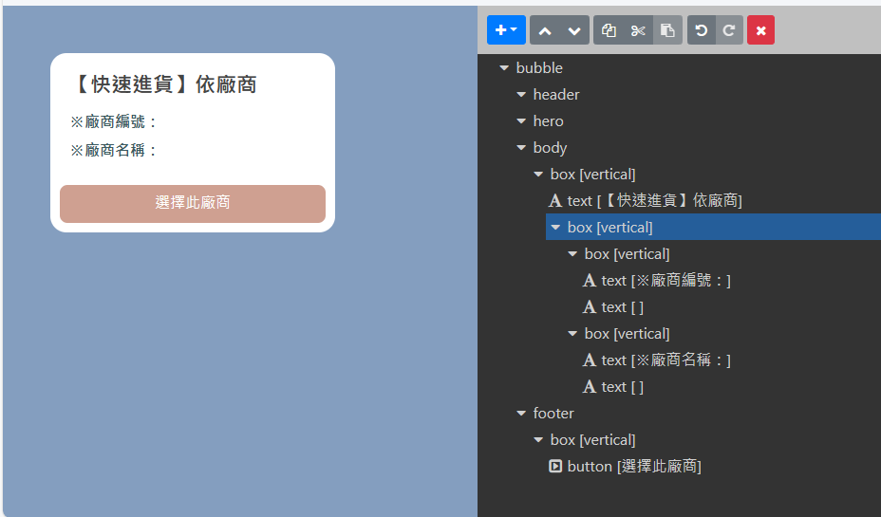

{

"type": "bubble",

"body": {

"type": "box",

"layout": "vertical",

"contents": [

{

"type": "text",

"text": "【快速進貨】依廠商",

"weight": "bold",

"size": "xl"

},

{

"type": "box",

"layout": "vertical",

"margin": "lg",

"spacing": "sm",

"contents": [

{

"type": "box",

"layout": "vertical",

"spacing": "sm",

"contents": [

{

"type": "text",

"text": "※廠商編號：",

"size": "md",

"flex": 1,

"color": "#3b5a5f",

"weight": "bold"

},

{

"type": "text",

"text": " ",

"wrap": true,

"color": "#666666",

"size": "md",

"flex": 5,

"weight": "bold"

}

]

},

{

"type": "box",

"layout": "vertical",

"spacing": "sm",

"contents": [

{

"type": "text",

"text": "※廠商名稱：",

"size": "md",

"flex": 1,

"color": "#3b5a5f",

"weight": "bold"

},

{

"type": "text",

"text": " ",

"wrap": true,

"color": "#666666",

"size": "md",

"flex": 5,

"weight": "bold"

}

]

}

]

}

]

},

"footer": {

"type": "box",

"layout": "vertical",

"spacing": "sm",

"contents": [

{

"type": "button",

"style": "primary",

"height": "sm",

"action": {

"type": "message",

"label": "選擇此廠商",

"text": "快速進貨-選擇廠商"

},

"color": "#cfa091"

}

],

"flex": 0

}

}